**PROJECT TITLE:**

**Automation of Staging Export using Work- Fusion**

1. Firstly, user has to check whether the export(automation) folder exists in E drive or not. Folder must consist of two different .xlsx documents. User has to open export.xlsx file
2. User has to make entry in export.xlsx file.

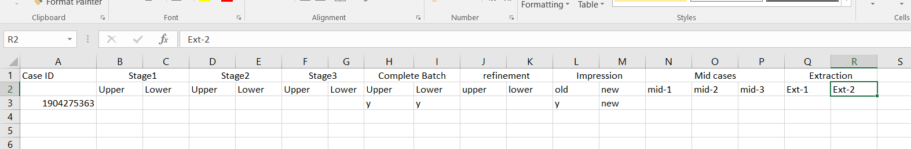

1. Entries of excel sheet are starting from A3. Case-id of patient is filled in A column. The case-id should be numeric with ten digits.
2. User must follow the following protocol to make appropriate entries in excel sheet. **Please take care that data is entered in lower case.**
   1. If the patient is having staging of both upper and lower arch and we have to stag and export both arch’s, then we put symbol **‘y’** in B and C column.
   2. If the patient is only upper arch in stage 1 then we put symbol **‘y’**

in B column.

* 1. Similarly, If the patient is only lower arch in stage 1 then we put symbol **‘y’** in C column.
  2. The entries which are not matching our requirements must remain empty.

1. Similarly, if the case is in stage2, stage3, complete batch or refinement same method is followed as stated in step 4.
2. L, M, N, O, P, Q, R columns are defined to describe the status of case, whether the case is new one, mid plan or it is having new impression. If the case is new one, then we put symbol **‘y’** in L column.
3. In some cases, patient undergoes rescan then new stl file is generated, in that case symbol **‘y’** in M column.
4. For mid treatment cases we have defined three categories. The mid cases are activated according to the stl file we get whether it is mid-1, mid-2 or mid-3. Similarly, there are two other cases of extraction.
5. After filling the entries user must save the file and launch the work-fusion application or you can run the application from right taskbar.

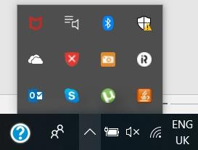

1. Sometimes work fusion may ask you a password. There is text file in export automation folder. User can check password from there. After launching application user have to open script file to play recording. It may appear on screen or not. So user must go to window->show view>other.

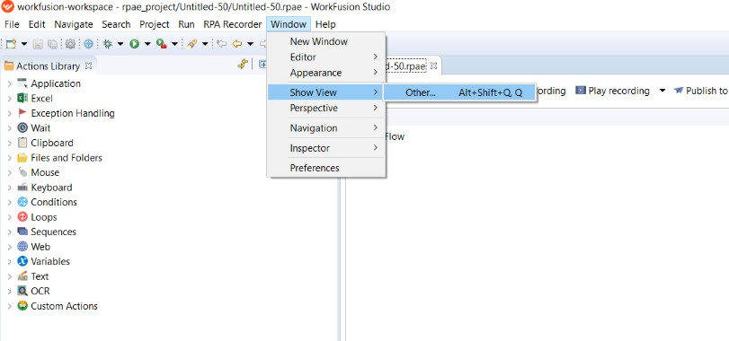

1. A dialog box will appear on the screen. Click on the media files and open it. Media files will be opened in the left side corner.

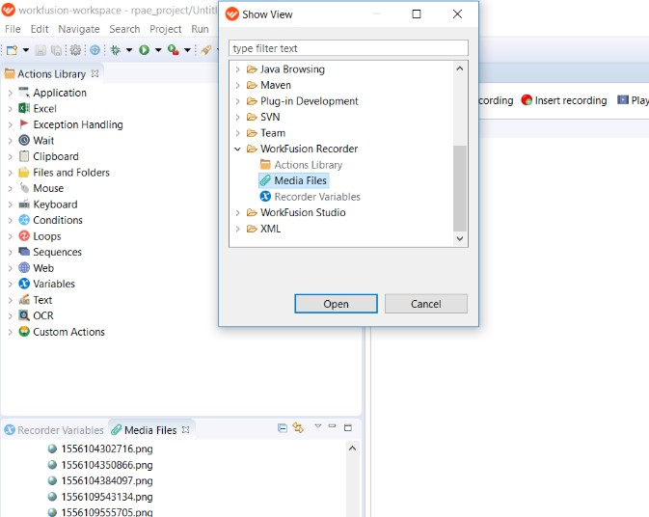

1. Double click on the export folder. Then click on the ***export.rpae*** . The file will load on right side.

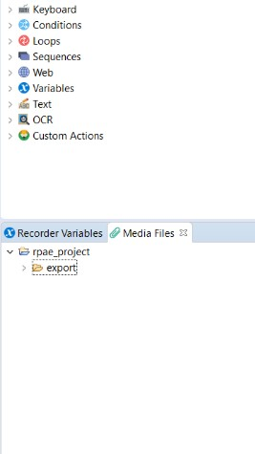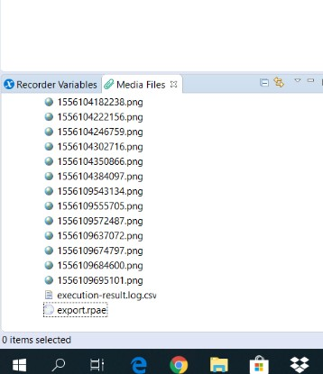

1. Click on the play recording to run the file. After we run the file a small window appears on the right side window.

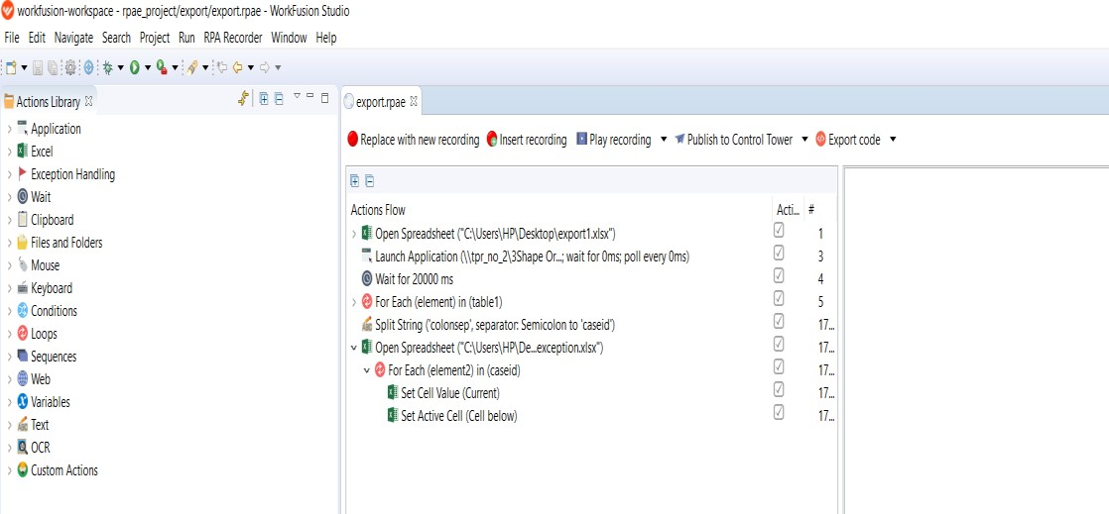

1. The window that appears on the right side must be shifted in upward direction to some extent.

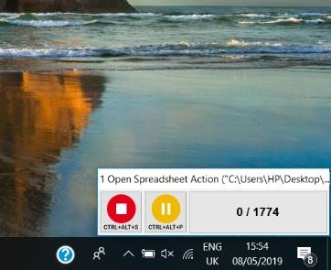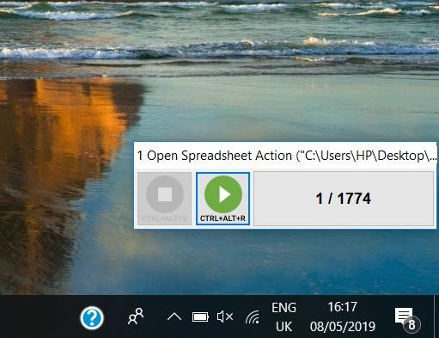

1. Sometimes it may execute an error like couldn’t connect to bot. In that case user must restart bot manager. User must check bot manager is always running.

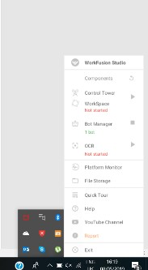

1. The names of stages must be exactly same as defined under the protocol stage.

|  |  |
| --- | --- |
| stage 1 | Staging and exporting is done in both upper and lower. |
| stage 2 | Staging and exporting is done in both upper and lower. |
| stage 3 | Staging and exporting is done in both upper and lower. |
| stage 1 upper | Upper is staged and export. |
| stage 2 upper | Upper is staged and export. |
| stage 3 upper | Upper is staged and export. |
| stage 1 lower | Lower is staged and export. |
| stage 2 lower | Lower is staged and export. |
| stage 3 lower | Lower is staged and export. |
| upper complete | Upper is exported without staging. |
| lower complete | Lower is exported without staging. |
| complete | Upper and Lower is exported without staging. |
| refinement | Staging and exporting is done in both upper and lower. |
| refinement upper | Upper is staged and export. |
| refinement lower | Lower is staged and export. |
| Mid-1 | When case comes in between. |
| Mid-2 | When case comes in between. |
| Mid-3 | When case comes in between. |
| New | When new design comes. |
| EXT-1 | For extraction-1 case. |
| EXT-2 | For extracton-2 case. |
| EXT-3 | For extracton-3 case. |

1. User must cross check the protocol designed for export, whether the name written inside the orthoanalyzer match the given protocol.

